Docker Documentation

1. Displaying the User name:

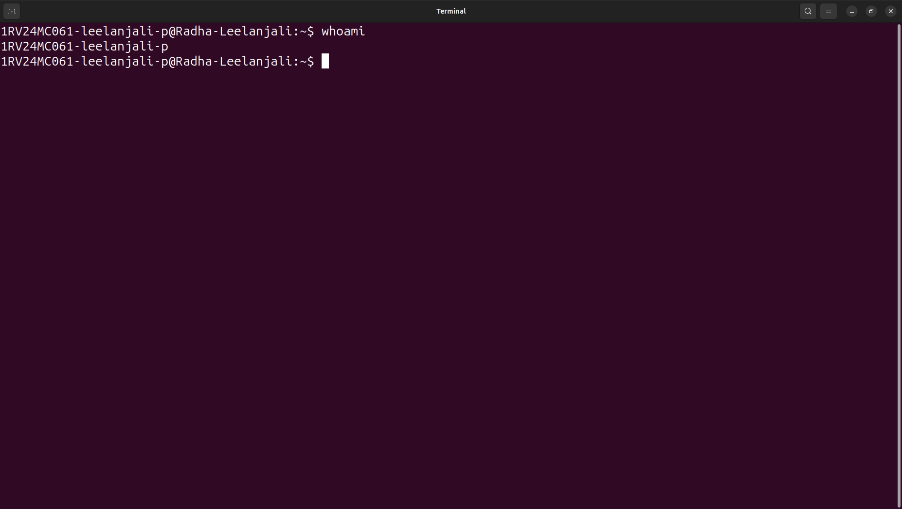
Fig 01: whoami command returns the username of the User

2. Command to set up the Docker apt repository. And then install and update Docker from the repository:

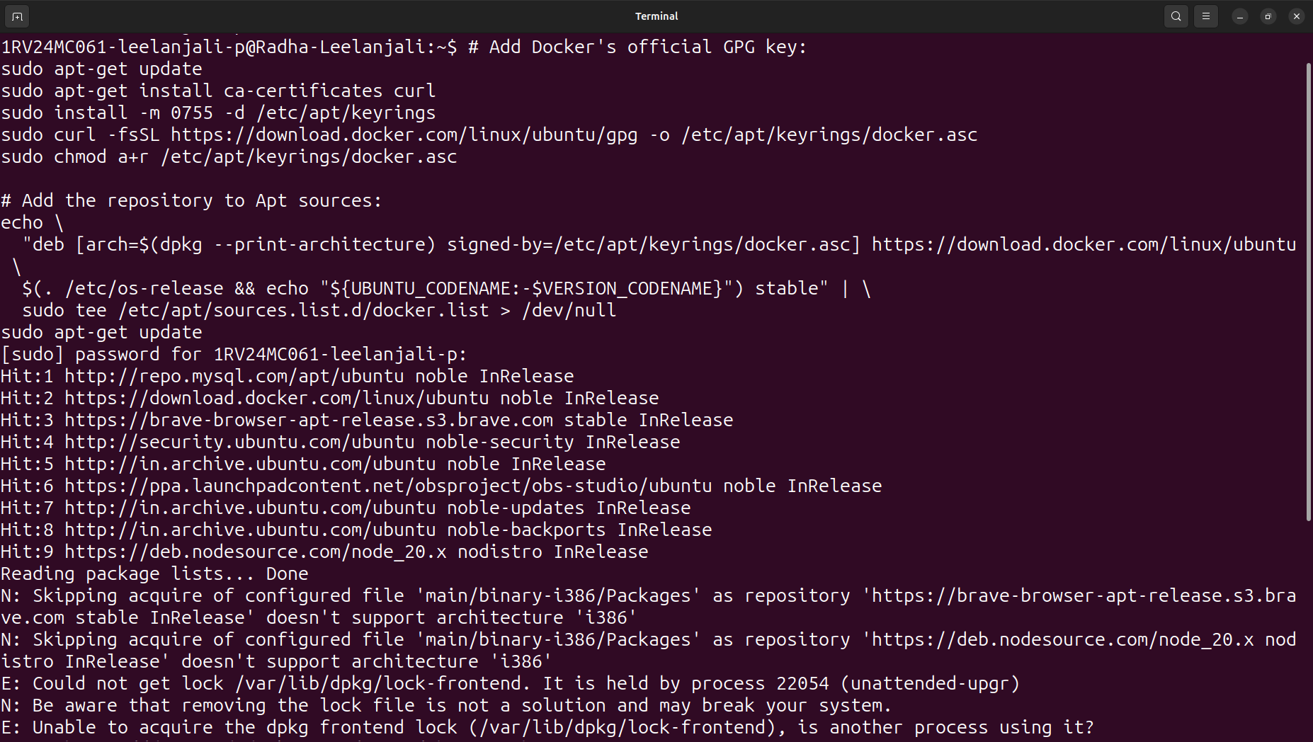
Fig 02: Set up Docker’s apt repository

3. Command to install the latest versions of Docker packages:

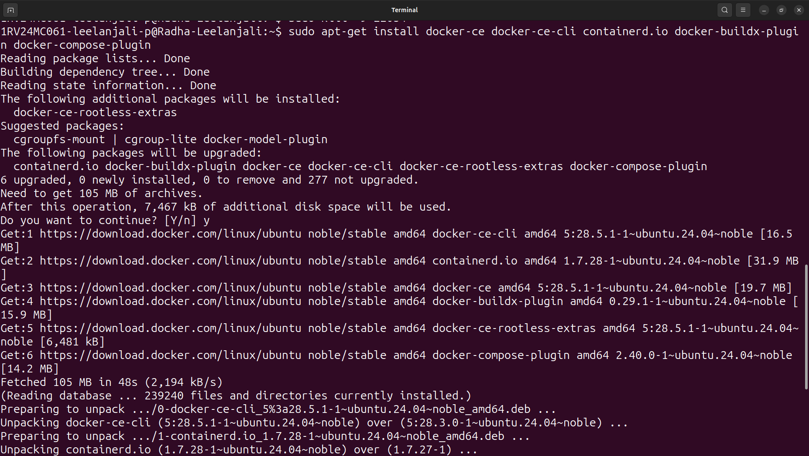
Fig 03: Latest versions of Docker packages

4. Docker commands to start and check the status of Docker:

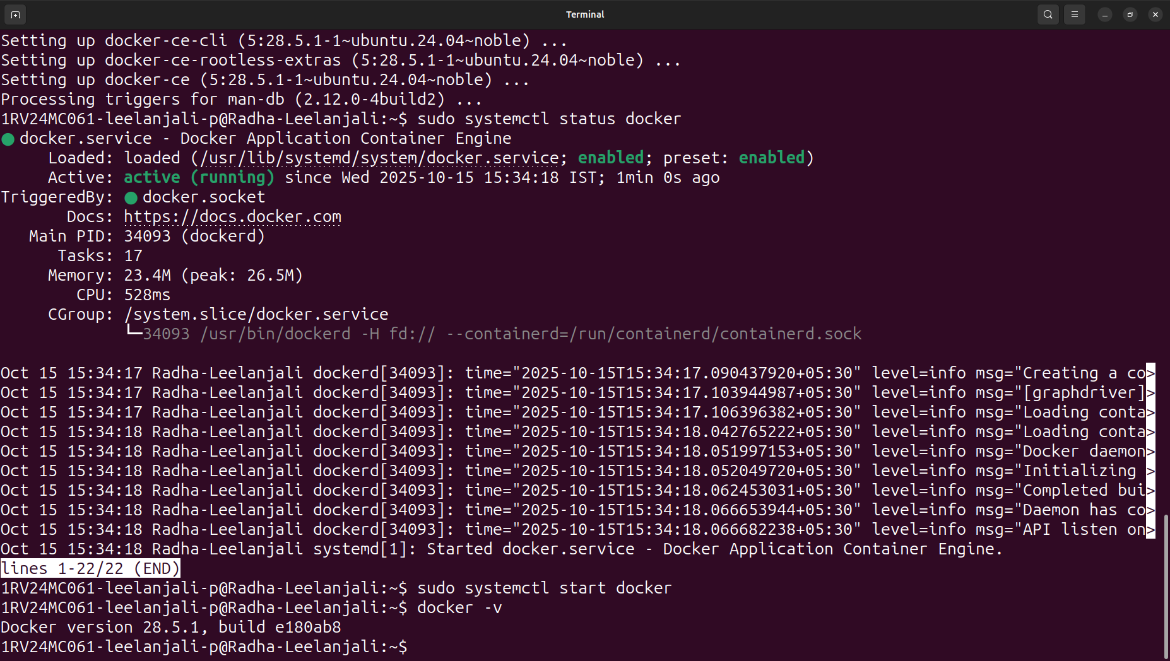
Fig 04: Image showing active status of Docker

